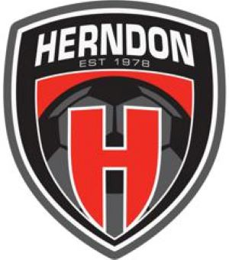

Board Of Directors Meeting November 14, 2023
7:00PM - 830PM
Minutes

Board Meeting started at 708p
Board Participants
- Aliona Gorea (Present)
- Basim Hawa (Present)
- Elise de Clerck (Present)
- JR Williamson (Present)
- Marylise Fabro (Present)
- Nico Delellis (Present)
- Stef Palmer (Present)
Staff Participants
- Nick Arzani (Present)
- Wassim Issa (Present)
End of Season Recap, Nick and Wassim
- Nick and other coaches heading to Argentina for coaching education
- Wassim proposed to roll team tournament fees into the club fees starting Fall 2024. This would cover 2 tournaments per season.
- All Star Recreation Tournament - Increased the number of teams from 21 last year to 27 this year.
- SFL will now be run by NCSL. NCSL plans to keep the process and the format the same without much change for the Spring 2024 season.
- Premier program had 24 participants expecting a large increase for the Spring 2024 season due to new U9 players getting prepared for tryouts for Fall season.
Board Only Session
- Staff performance reviews to be held in December. Review past performance and improvements for the future.
- Voting Status
  - Veo Cameras for Teams – Unanimously approved the purchase of 13 cameras.
  - New Travel Manager Role – Unanimously approved the part-time position to help with tryouts and tournament registration. Wassim will need to come back to the Board if there is a desire to change the role to a full-time position; at which point the role will need to be publicly advertised and competed.
Meeting ended at 9p

