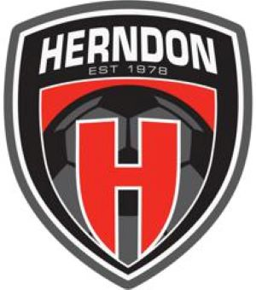

Board Of Directors Meeting October 10 2023
7:00PM - 830PM
Minutes

Board Meeting started at 708p
Board Participants
- Aliona Gorea (Present)
- Basim Hawa (Present)
- Elise de Clerck (Present)
- JR Williamson (Present)
- Marylise Fabro (Present)
- Nico Delellis (Present)
- Stef Palmer (Present)
Non-Disclosure Agreements (NDA)
- All board members are required to sign an NDA. This was the policy in years past but was not completed for the last 2 years. The policy has been reinstated. NDAs will be collected and filed on the HYS SharePoint site.
Major Rhythms and Focus for the Board
- Yearly Calendar
  - Monthly Topics
  - 6 Months/Yearly Member Satisfaction review
- How to make meetings more efficient
- Develop a discipline/escalation process and procedure
- More focus on the mission and performance of HYS
- New Travel Manager Position discussed
- Special Scholarship Fund suggested to help our neediest of players
- Two New Committees to be formed that will include members from the club:
  - Policy, Procedure and Protocol (including progressive discipline)
  - Fundraising and Sponsorship
Meeting ended at 9p

